*Faculty of Computer Science and Mathematics*

**CS245 : Bachelor of Computer Science (Hons) Data Communication and Networking**

**ITT 450**

**INFORMATION & NETWORK SECURITY**

**LAB ASSIGNMENT 1**

**Kali Linux Command**

**Name : Amira Hasfarisha binti Abdul Halim**

**Class : M3CS2453A**

**ID : 2017977383**

**Lecturer : Sir Mohd Ali Mohd Isa**

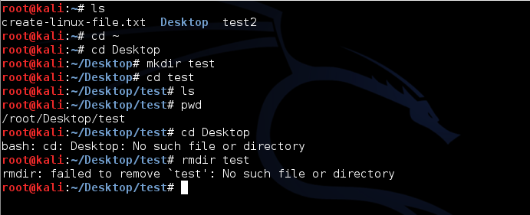1.

ls – ls command use to list information about files.

2.

 cd – use to change directory.

3.

 mkdir – use to create new folders.

4.

 pwd – use to print name of current directory

5.

rmdir – use to remove folders.

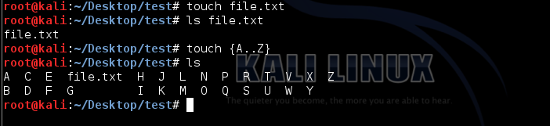6.

touch – use to create a quick file of any extension. Used to modify the access/modification

time stamps of files.

7.

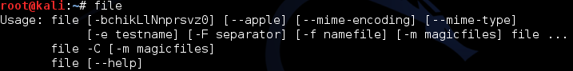 Ping – use to check other system are reachable from the host system.

8.

file – used to determine file type.

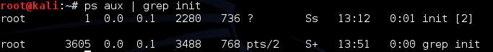9.

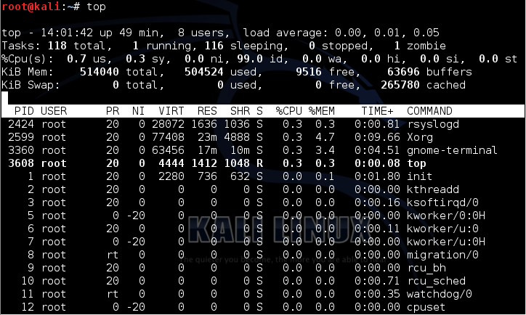 grep – used to search files for lines that match a given pattern.

10.

top – used to list processes running on the system.

11.

chmod – used to change files permissions.

12.

chown – used to change file owner and group.

13.

Kill – used to stop a process to running.

14.

Uname – used to print system information.

15.

Uptime – used to show uptime.

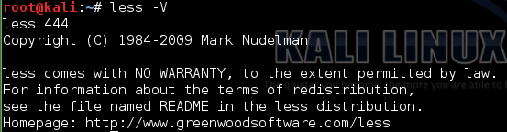16.

less – used to display output one screen at a time.

17.

List the contents of the current directory with ls, using more command to display the

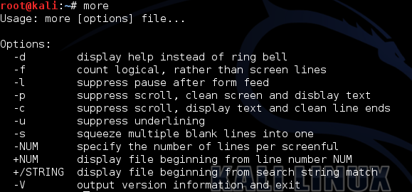 list one screen at a time.

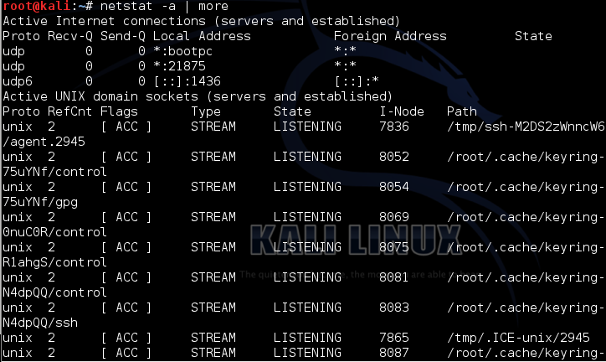18.

netstat – used to check networking information.

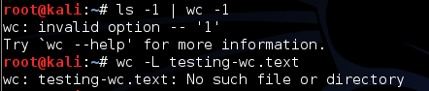19.

 wc – used to print byte, word and line counts.

20.

ln – used to create a symbolic link to a file.

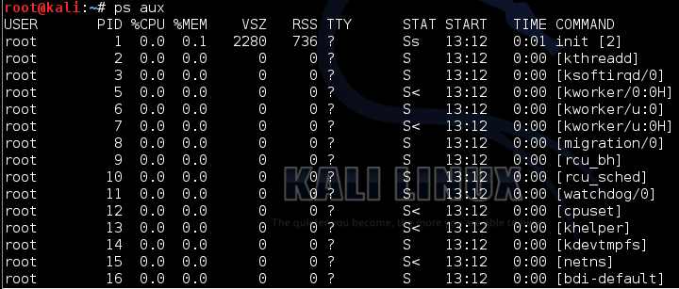21.

ps – used to displays information of current active process.

22.

rm –used to remove files or directories.



23.

cat – used to concatenate and print (display) the content of files.